#### **Avoid Food Wastage**

**ABSTRACT**

This project is used to manage wastage foods in a useful way. Every day the people are wasting lots of foods. So we have to reduce that food wastage problem through online. If anyone have wastage foods they are entering their food quantity details and their address in that application and then the admin maintain the details of food donator.

The donator can create the account and whenever they are having wastage food they can login and give request to the admin. And the admin also maintain the buyer(orphanage,poor people,..) details too. After the admin view the donator request and give the alert message like time to come and collect the food.

And the admin collect foods from donator through their nearby agent then provide to nearest orphanages or poor people. After receiving the food from the agent by admin and give alert message to that donator.

This project is food redistribution is an enormously successful social innovation that tackles food waste and food poverty. The user’s details are maintained confidential because it maintains a separate account for each user.

**EXISTING SYSTEM**

In existing system if anyone have extra food because of any function or in their home it will be become waste because instantly there is no way to share with anyone if they are having lots of food . even if they want to give that extra food to any orphanage or poor people they don’t have time or don’t have an idea about that

So that we have create a application for sponsor that extra food to poor people or nearby orphanage.

**PROPOSED SYSTEM**

In proposed system we are reduce that food wastage using that application.

This project is food redistribution is an enormously successful social innovation that tackles food waste and food poverty. the admin collect foods from donator through their nearby agent then provide to nearest orphanages or poor people. After receiving the food from the agent by admin and give alert message to that donator through this way we can reduce food wastage problem.

**MODULES**

In this project consist of the different types of module.The modules are:

1.Admin Module

2.Donator Module

3.Agent Module

4.Comments Module

**1. Admin** **Module:**

In admin module,The administrator maintain the agent details as well as the donator details.The administrator collect the food from the agent. The administrator also send the agent details to donator.

**2.Donator Module**

In donator module,the donator give the wastage of food to the orphanage. The donator give the request to the admin for the purpose of to collect the wastage food.The donator view the agent details.

**3. Agent Module:**

In Agent module,the agent maintain the donator details.The agent give the request to the admin for collect the food from the donator.After collect the food the agent give the alert message for the donator.

**4.Comments Module**

In this module the user give the comments for this site.While entering the comments, user must enter the following details such as, user name, email id and user comment. The admin can view user comments and details.

**Software requirements**:

* Operating System : Windows
* Technology : PHP
* Web Technologies : Html, JavaScript, CSS
* IDE : Notepad++
* Web Server : XAMPP
* Database : My SQL

**Hardware requirements**:

* Hardware - Pentium
* Speed - 1.1 GHz
* RAM - 1GB
* Hard Disk - 20 GB
* Key Board - Standard Windows Keyboard
* Mouse - Two or Three Button Mouse
* Monitor - SVGA

**INPUT DESIGN**

The input design is the link between the information system and the user. It comprises the developing specification and procedures for data preparation and those steps are necessary to put transaction data in to a usable form for processing can be achieved by inspecting the computer to read data from a written or printed document or it can occur by having people keying the data directly into the system. The design of input focuses on controlling the amount of input required, controlling the errors, avoiding delay, avoiding extra steps and keeping the process simple. The input is designed in such a way so that it provides security and ease of use with retaining the privacy. Input Design considered the following things:

* What data should be given as input?
* How the data should be arranged or coded?
* The dialog to guide the operating personnel in providing input.
* Methods for preparing input validations and steps to follow when error occur.

**OBJECTIVES**

1.Input Design is the process of converting a user-oriented description of the input into a computer-based system. This design is important to avoid errors in the data input process and show the correct direction to the management for getting correct information from the computerized system.

2. It is achieved by creating user-friendly screens for the data entry to handle large volume of data. The goal of designing input is to make data entry easier and to be free from errors. The data entry screen is designed in such a way that all the data manipulates can be performed. It also provides record viewing facilities.

3.When the data is entered it will check for its validity. Data can be entered with the help of screens. Appropriate messages are provided as when needed so that the user will not be in maize of instant. Thus the objective of input design is to create an input layout that is easy to follow

**OUTPUT DESIGN**

A quality output is one, which meets the requirements of the end user and presents the information clearly. In any system results of processing are communicated to the users and to other system through outputs. In output design it is determined how the information is to be displaced for immediate need and also the hard copy output. It is the most important and direct source information to the user. Efficient and intelligent output design improves the system’s relationship to help user decision-making.

1. Designing computer output should proceed in an organized, well thought out manner; the right output must be developed while ensuring that each output element is designed so that people will find the system can use easily and effectively. When analysis design computer output, they should Identify the specific output that is needed to meet the requirements.

2.Select methods for presenting information.

3.Create document, report, or other formats that contain information produced by the system.

The output form of an information system should accomplish one or more of the following objectives.

* Convey information about past activities, current status or projections of the
* Future.
* Signal important events, opportunities, problems, or warnings.
* Trigger an action.
* Confirm an action.

### SYSTEM TEST

### The purpose of testing is to discover errors. Testing is the process of trying to discover every conceivable fault or weakness in a work product. It provides a way to check the functionality of components, sub assemblies, assemblies and/or a finished product It is the process of exercising software with the intent of ensuring that the

### Software system meets its requirements and user expectations and does not fail in an unacceptable manner. There are various types of test. Each test type addresses a specific testing requirement.

**TYPES OF TESTS**

**Unit testing**

Unit testing involves the design of test cases that validate that the internal program logic is functioning properly, and that program inputs produce valid outputs. All decision branches and internal code flow should be validated. It is the testing of individual software units of the application .it is done after the completion of an individual unit before integration. This is a structural testing, that relies on knowledge of its construction and is invasive. Unit tests perform basic tests at component level and test a specific business process, application, and/or system configuration. Unit tests ensure that each unique path of a business process performs accurately to the documented specifications and contains clearly defined inputs and expected results.

**Integration testing**

Integration tests are designed to test integrated software components to determine if they actually run as one program. Testing is event driven and is more concerned with the basic outcome of screens or fields. Integration tests demonstrate that although the components were individually satisfaction, as shown by successfully unit testing, the combination of components is correct and consistent. Integration testing is specifically aimed at exposing the problems that arise from the combination of components.

**Functional test**

Functional tests provide systematic demonstrations that functions tested are available as specified by the business and technical requirements, system documentation, and user manuals.

Functional testing is centered on the following items:

Valid Input : identified classes of valid input must be accepted.

Invalid Input : identified classes of invalid input must be rejected.

Functions : identified functions must be exercised.

Output : identified classes of application outputs must be exercised.

Systems/Procedures : interfacing systems or procedures must be invoked.

Organization and preparation of functional tests is focused on requirements, key functions, or special test cases. In addition, systematic coverage pertaining to identify Business process flows; data fields, predefined processes, and successive processes must be considered for testing. Before functional testing is complete, additional tests are identified and the effective value of current tests is determined.

**System Test**

System testing ensures that the entire integrated software system meets requirements. It tests a configuration to ensure known and predictable results. An example of system testing is the configuration oriented system integration test. System testing is based on process descriptions and flows, emphasizing pre-driven process links and integration points.

**White Box Testing**

White Box Testing is a testing in which in which the software tester has knowledge of the inner workings, structure and language of the software, or at least its purpose. It is purpose. It is used to test areas that cannot be reached from a black box level.

**Black Box Testing**

Black Box Testing is testing the software without any knowledge of the inner workings, structure or language of the module being tested. Black box tests, as most other kinds of tests, must be written from a definitive source document, such as specification or requirements document, such as specification or requirements document. It is a testing in which the software under test is treated, as a black box .you cannot “see” into it. The test provides inputs and responds to outputs without considering how the software works.

**Unit Testing**

Unit testing is usually conducted as part of a combined code and unit test phase of the software lifecycle, although it is not uncommon for coding and unit testing to be conducted as two distinct phases.

**Test strategy and approach**

Field testing will be performed manually and functional tests will be written in detail.

**Test objectives**

* All field entries must work properly.
* Pages must be activated from the identified link.
* The entry screen, messages and responses must not be delayed.

**Features to be tested**

* Verify that the entries are of the correct format
* No duplicate entries should be allowed
* All links should take the user to the correct page.

# Integration Testing

Software integration testing is the incremental integration testing of two or more integrated software components on a single platform to produce failures caused by interface defects.

The task of the integration test is to check that components or software applications, e.g. components in a software system or – one step up – software applications at the company level – interact without error.

**Test Results:** All the test cases mentioned above passed successfully. No defects encountered.

**Acceptance Testing**

User Acceptance Testing is a critical phase of any project and requires significant participation by the end user. It also ensures that the system meets the functional requirements.

**Test Results:** All the test cases mentioned above passed successfully. No defects encountered.

**DATA FLOW DIAGRAM**

**USER**

duser.png

**AGENT**

**dagent.png**

**ADMIN**

**dadmin.png**

**Usecase Diagram**

**fusecase.png**

**CLASS DIAGRAM**

**fclass.png**

**SEQUENCE DIAGRAM**

**User**

**fuseq.png**

**AGENT**

**fagseq.png**

**ADMIN**

**fadseq.png**

**ACTIVITY DIAGRAM**

**User**

**fuseact.png**

**Agent**

**fagact.png**

**Admin**

**fadact.png**

**SCREEN SHOTS**

**Donate Food**

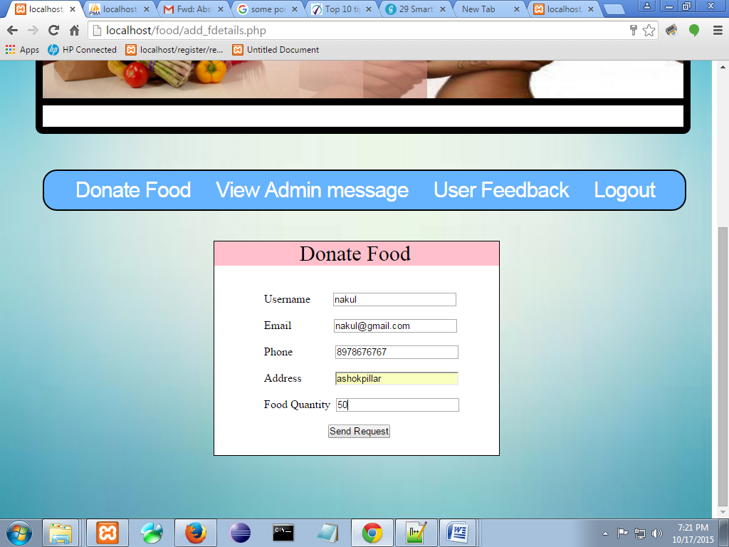

**Add Agent Details**

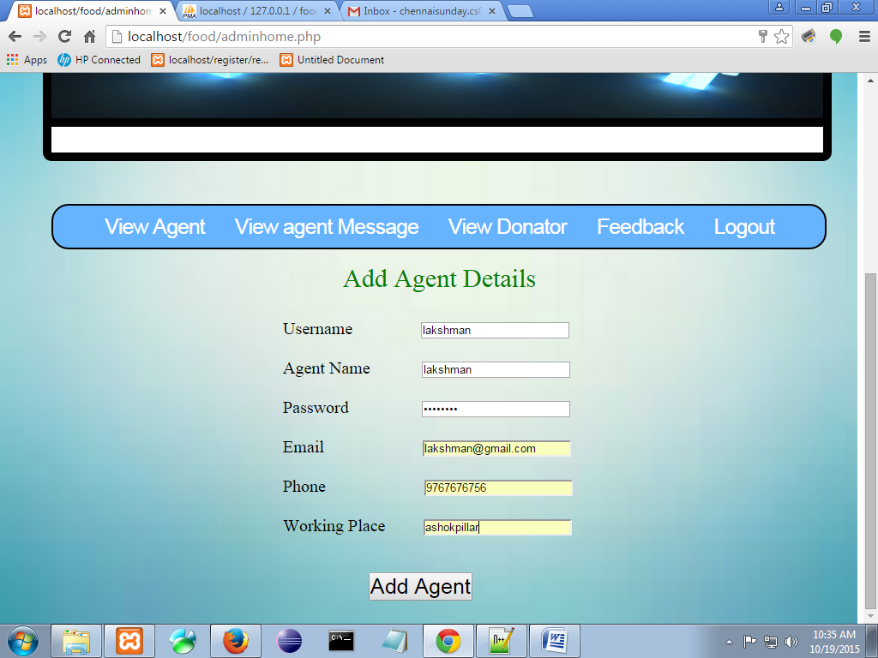

**View Donator Details**

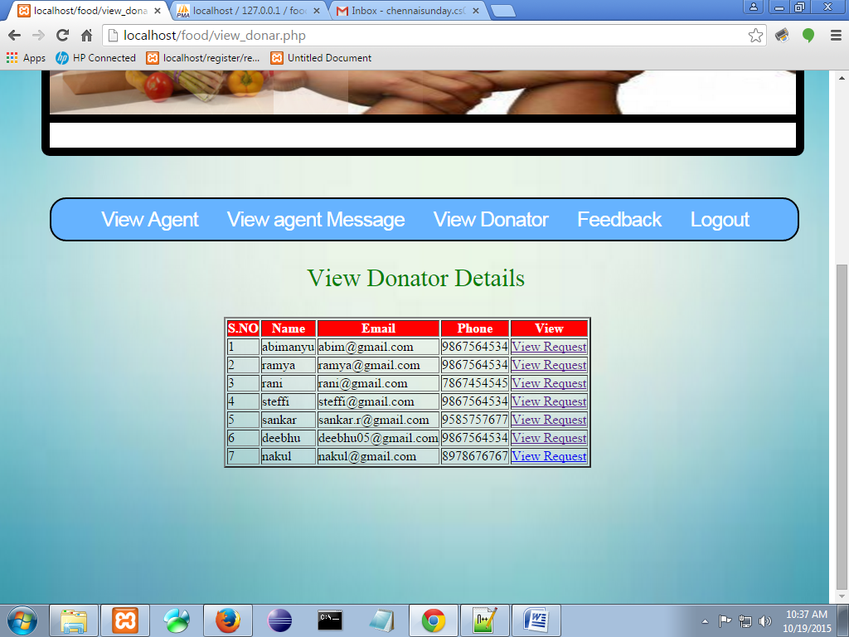

**Send Request To Agent**

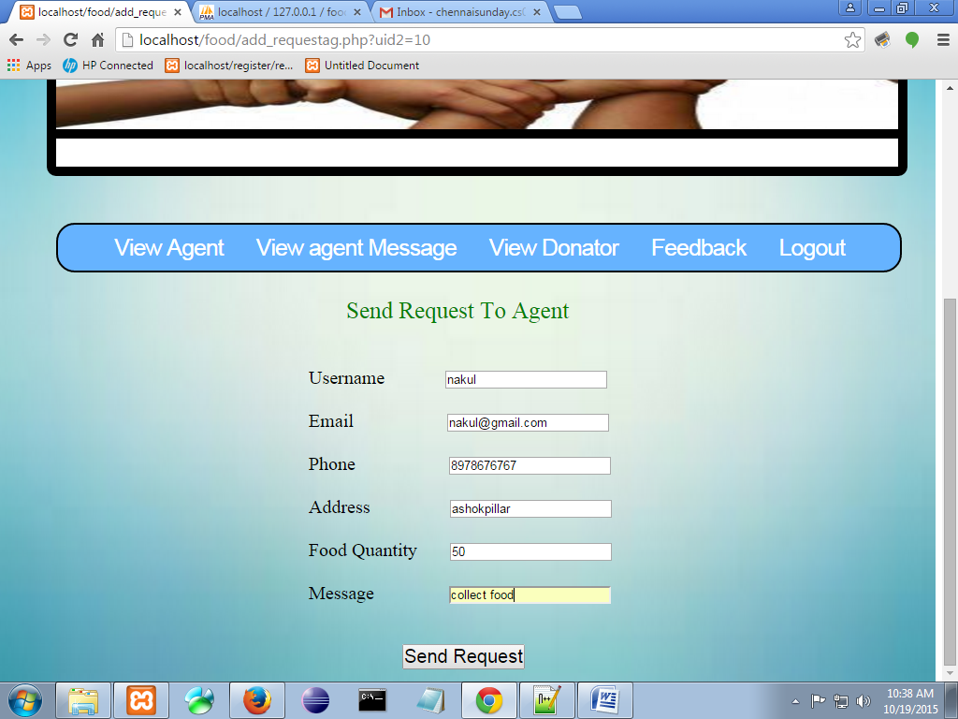

**Send Message To Donor**

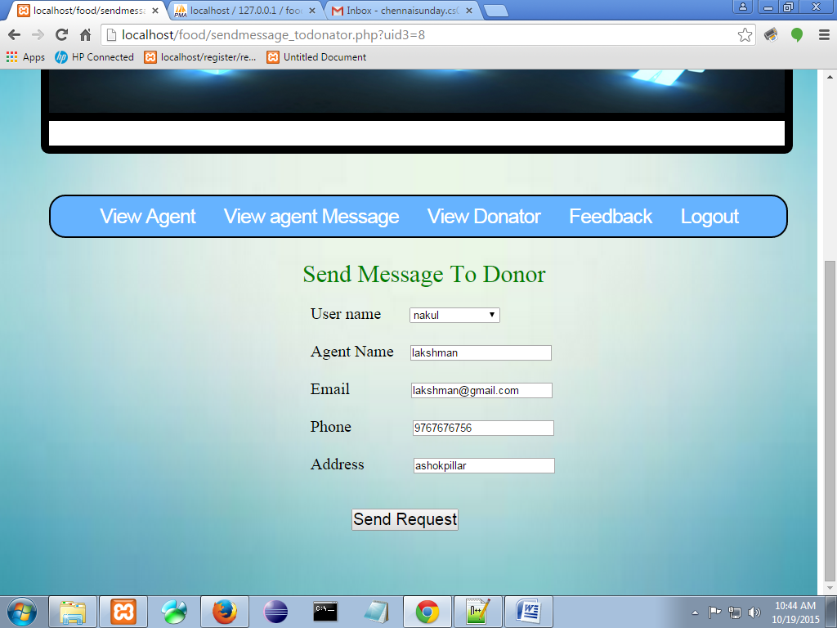

**Donor View message from Admin**

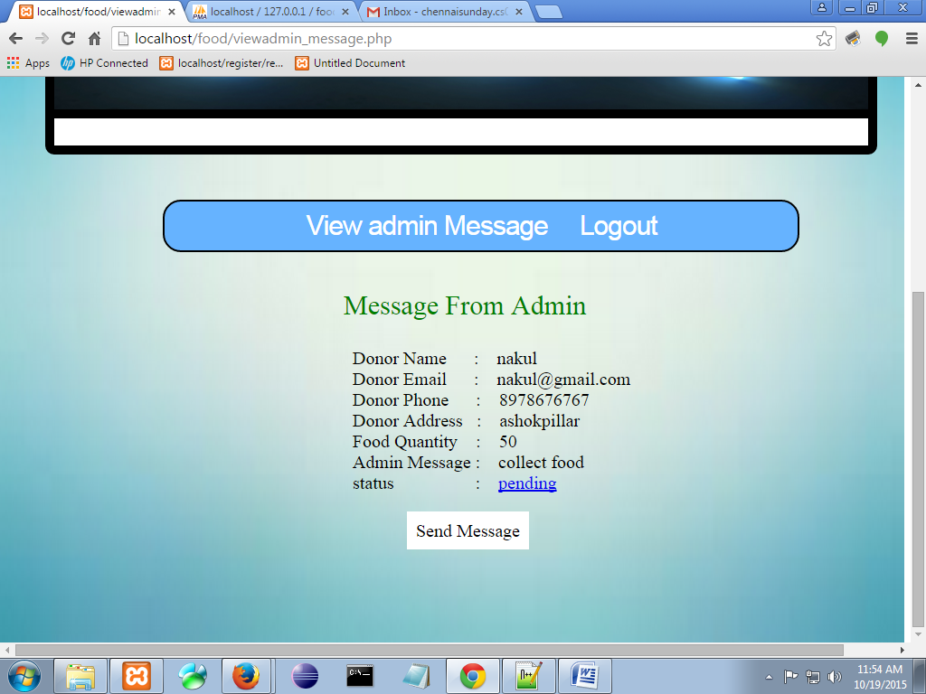

**View Agent Message**

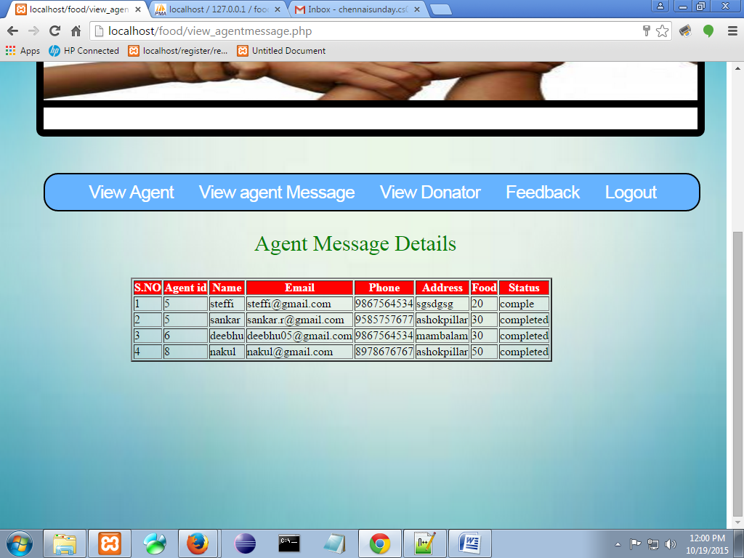

**View Message From Admin**

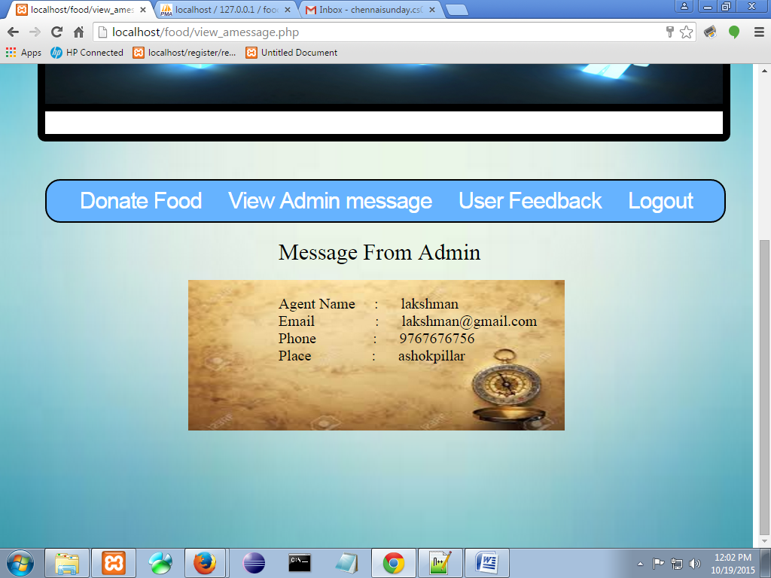

**CONCLUSION**

The Avoid Food Wastage project can be efficiently used by to donate the waste food.The donator donate the food by adding the information about in this site.The admin maintain the donator details as well as the agent details.The admin send the donator details to the agent.The agent collect the food from the donator and to give the nearest orphanage.